**Geometry Vocabulary**

**Lesson 11:**

**Acute Triangle**

Definition:  
If an angle measures more than 0° but less than 90°, the angle is **acute.**

Illustration:

contentABC below is an acute angle.

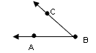

Examples:

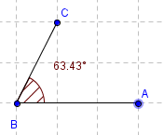

**Congruent Angles**

Definition: Congruent Angles have the same angle.

Illustration:

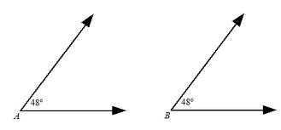

Examples:

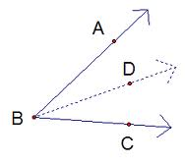

**Acute Angle**

Definition: An angle that is less than 90 degrees.

Illustration:

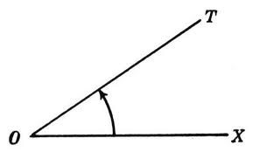

Examples:

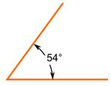

**Right Angle**

Definition: A right angle is exactly 90 degrees.

Illustration:

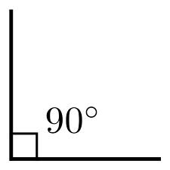

Examples:



**Obtuse Angle**

Definition: An angle larger than 90 degrees, but less than 180.

Illustration:

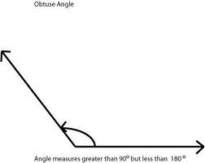

Examples:

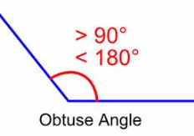

**Straight Angle**

Definition: A straight angle is 180 degrees.

Illustration:

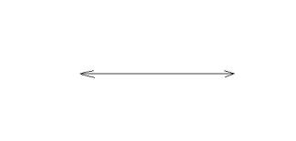

Examples:

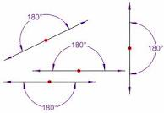

**Reflex Angle**

Definition: A reflex angle is more than 180 degrees but less than 360 degrees.

Illustration:

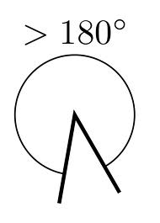

Examples:

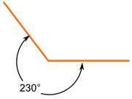

**Adjacent Angles**

Definition: Two angles are Adjacent if they have a common side and a common vertex.

Illustration:

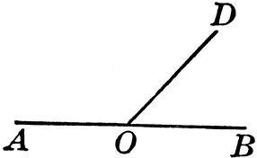

Examples:

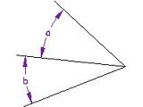

**Supplementary Angles**

Definition: Two angles are supplementary if they add up to 180 degrees.

Illustration:

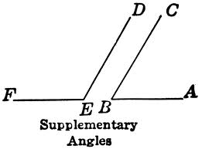

Examples:

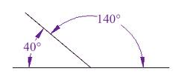

**Complementary Angles**

Definition: Two angles are complementary if they add up to 90 degrees.

Illustration:

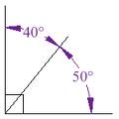

Examples:

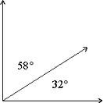

**Vertical Angles**

Definition: Vertical Angles are the angles opposite each other when two lines cross.

Illustration:

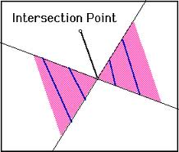

Examples:

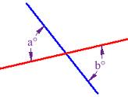

**Angle Bisector**

Definition: A line or ray that divides an angle in half.

Illustration:

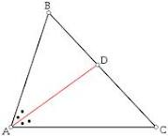

Examples:

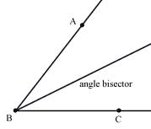

**Linear Pair**

Definition: Two angles that are adjacent and supplementary.

Illustration:

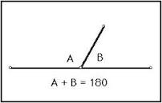

Examples: Angles 3 and 4 are a linear pair.

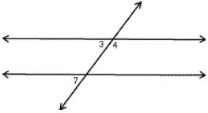

**Protractor**

Definition: An instrument for measuring angles.

Illustration:

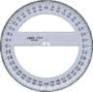

Examples:

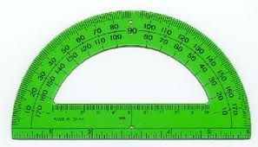

**Angle Addition Postulate**

Definition: States that if a point S lies in the interior of <PQR, then

<PQS + <SQR = <PQR

Illustration:

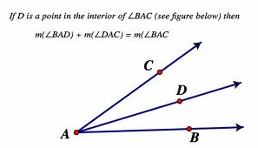

Examples: <BOC + <AOB = <PQR

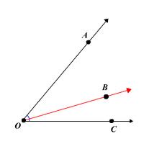

**Perpendicular Lines**

Definition: A line is perpendicular to another if they meet at 90 degrees.

Illustration:

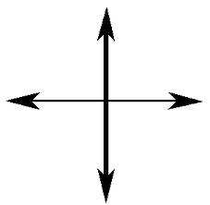

Examples:

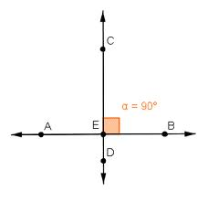

**Parallel Lines**

Definition: Lines are parallel if they are always the same distance apart.

Illustration:

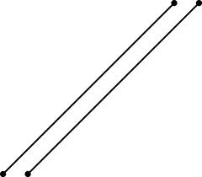

Examples:

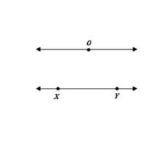

**Transversal Lines**

Definition: A line that cuts across two or more lines.

Illustration:

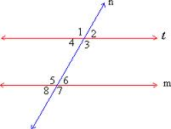

Examples:



**Alternate Interior Angles**

Definition: Pairs of angles on opposite sides of the transversal but inside the two lines.

Illustration:

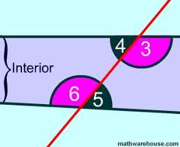

Examples: Angle 3 and 6 are alternate interior angles.

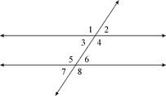

**Alternate Exterior Angles**

Definition: Pairs of angles on opposite sides of the transversal but outside the two lines.

Illustration:

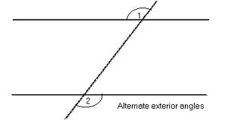

Examples:

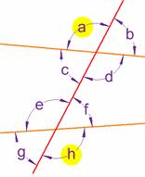

**Corresponding Angles**

Definition: Two congruent angles, both lying on the same side of the transversal and situated the same way on two different parallel lines.

Illustration:

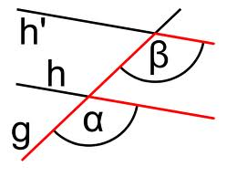

Examples: Angle C and B are corresponding angles.

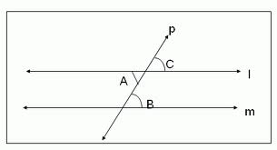

**Consecutive Interior Angles**

Definition: The pairs of angles on one side of the transversal but inside the two lines.

Illustration:

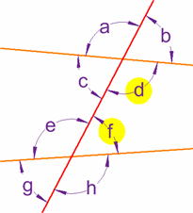

Examples:

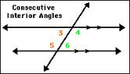

**Same-Side Exterior Angles**

Definition: Two angles outside the two parallel lines along the same side of a transversal line.

Illustration: Angle 1 and 7

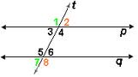

Examples: Angles E and F

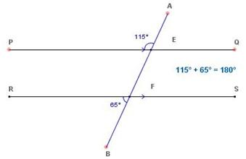

**Week 12 Vocabulary**

**Acute Triangle**

Definition: A triangle each of whose angles measures less than 90 degrees.

Illustration: 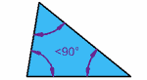

Examples: 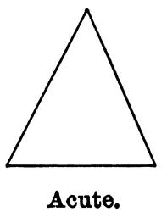

**Right Triangle**

Definition: A triangle that contains a right angle.

Illustration: [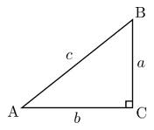](http://www.google.com/imgres?um=1&hl=en&sa=N&biw=1306&bih=597&tbm=isch&tbnid=WbzQkf4HnLfqnM:&imgrefurl=http://en.wikipedia.org/wiki/Right_triangle&docid=FH8MUTlx2ED4HM&imgurl=http://upload.wikimedia.org/wikipedia/commons/thumb/6/6f/Rtriangle.svg/220px-Rtriangle.svg.png&w=220&h=187&ei=R-8BT_fWHon-ggeP2biMDg&zoom=1)

Examples: [](http://www.google.com/imgres?um=1&hl=en&sa=N&biw=1306&bih=597&tbm=isch&tbnid=55gV3Pca3MzYkM:&imgrefurl=http://www.dpchallenge.com/image.php?IMAGE_ID=174560&docid=Ibmz00GCNKnmQM&imgurl=http://images.dpchallenge.com/images_challenge/0-999/338/800/Copyrighted_Image_Reuse_Prohibited_174560.jpg&w=640&h=481&ei=R-8BT_fWHon-ggeP2biMDg&zoom=1)

**Obtuse Triangle**

Definition: A triangle with an obtuse angle.

Illustration: [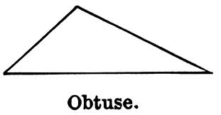](http://www.google.com/imgres?um=1&hl=en&biw=1306&bih=597&tbm=isch&tbnid=8XImekHTyjtd4M:&imgrefurl=http://etc.usf.edu/clipart/38600/38600/triwent7_38600.htm&docid=NPhuOxgxd400fM&imgurl=http://etc.usf.edu/clipart/38600/38600/Triwent7_38600_lg.gif&w=700&h=366&ei=be8BT4yKAuLu0gGQh6iXAg&zoom=1)

Examples: [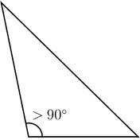](http://www.google.com/imgres?um=1&hl=en&biw=1306&bih=597&tbm=isch&tbnid=IWscTQ2cEosjMM:&imgrefurl=http://en.wiktionary.org/wiki/obtuse_triangle&docid=GbcpkzQJmR6cMM&imgurl=http://upload.wikimedia.org/wikipedia/commons/thumb/0/05/Triangle.Obtuse.svg/220px-Triangle.Obtuse.svg.png&w=220&h=220&ei=be8BT4yKAuLu0gGQh6iXAg&zoom=1)

**Equiangular Triangle**

Definition: A triangle with equal angles.

Illustration: [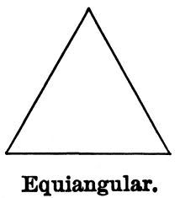](http://www.google.com/imgres?um=1&hl=en&biw=1306&bih=597&tbm=isch&tbnid=ug_yq0XOXpZS_M:&imgrefurl=http://etc.usf.edu/clipart/38600/38602/triwent9_38602.htm&docid=HQDGs_fV23D2FM&imgurl=http://etc.usf.edu/clipart/38600/38602/Triwent9_38602_lg.gif&w=700&h=769&ei=lu8BT4-eKNTTgQf1gJm1Ag&zoom=1)

Examples: [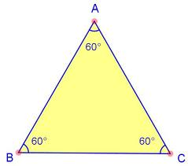](http://www.google.com/imgres?um=1&hl=en&biw=1306&bih=597&tbm=isch&tbnid=TTyPwFTn8j9lJM:&imgrefurl=http://www.proprofs.com/flashcards/story.php?title=geometry-flashcards_6&docid=iHLZXx4cg0_NfM&imgurl=http://www.proprofs.com/flashcards/upload/a3979269.jpg&w=525&h=465&ei=lu8BT4-eKNTTgQf1gJm1Ag&zoom=1)

**Scalene Triangle**

Definition: A triangle with three unequal sides.

Illustration:

Examples:

**Equilateral Triangle**

Definition: A triangle that has three equal sides.

Illustration:

Examples:

**Isosceles Triangle**

Definition: A triangle with at least two equal sides.

Illustration:

Examples:

**Triangle Sum Theorem**

Definition: The sum of the interior angles of any triangle is equal to 180 degrees.

Illustration:

Examples:

**Exterior Angle Theorem**

Definition: An measure of an exterior angle of a triangle is equal to the sum of the measures of the two non-adjacent interior angles.

An exterior angle is formed by one side of a triangle and the extension of an adjacent side of the triangle.

Illustration: 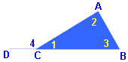

Examples:

**Orthocenter**

Definition:

Illustration:

Examples:

**Centroid**

Definition:

Illustration:

Examples:

**Incenter**

Definition:

Illustration:

Examples:

**Circumcenter**

Definition:

Illustration:

Examples:

**Reflexive Property**

Definition:

Illustration:

Examples:

**SSS Postulate (Side-Side-Side)**

Definition:

Illustration:

Examples:

**SAS Postulate (Side-Angle-Side)**

Definition:

Illustration:

Examples:

**ASA Postulate (Angle-Side-Angle)**

Definition:

Illustration:

Examples:

**AAS Theorem (Angle-Angle-Side)**

Definition:

Illustration:

Examples:

**HL Theorem (Hypotenuse-Leg)**

Definition:

Illustration:

Examples:

**Corresponding-Parts-of-Congruent-Triangles (CPCTC)**

Definition:

Illustration:

Examples:

Week 13

Ratio

Definition: The quantitative relation between two amounts showing the number of times one value contains or is contained within the other.

Illustration:

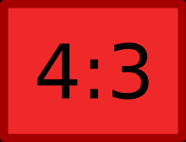

Examples:

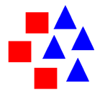

Write it as a fraction, using the word “to”, or using a semi colon.

Proportion

Definition: A part, share, or number considered in comparative relation to a whole.

Illustration:

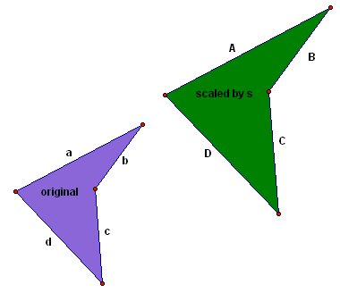

Examples:

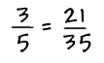

Congruent

Definition: Two objects are congruent if they have the same dimensions and shape

Illustration:

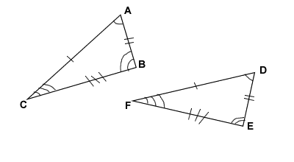

Examples:

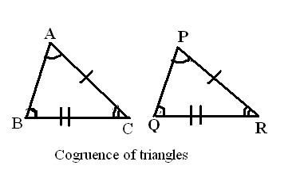

Similar Triangles

Definition: Triangles whose corresponding angles are equal; the corresponding sides are then proportional in length.

Illustration:

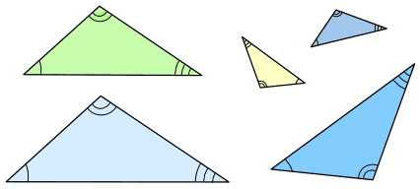

Examples:

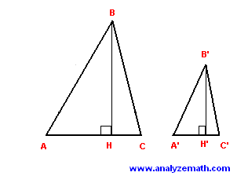

Corresponding Angles

Definition: Corresponding angles are created where a transversal crosses other (usually parallel) lines.

Illustration:

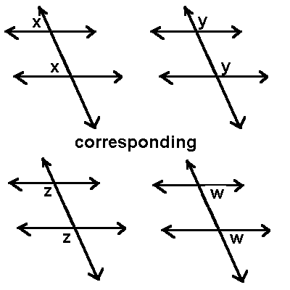

Examples:

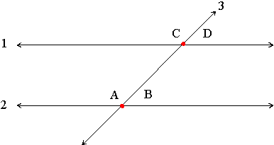

Cooresponding Sides

Definition: If the relative position of two sides is same in two figures

Illustration:

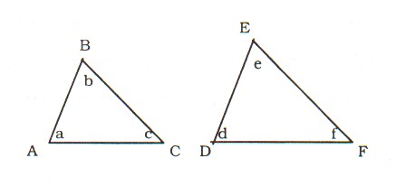

Examples:

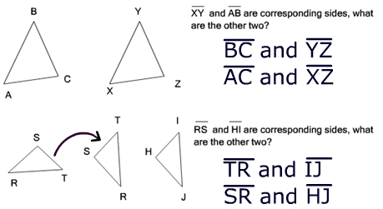  
Angle-Angle Similarity Postulate

Definition: states that if two angles and the non-included side one triangle are congruent to two angles and the non-included angle of another triangle, then these two triangles are congruent.

Illustration:

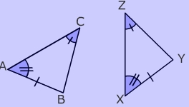

Examples:

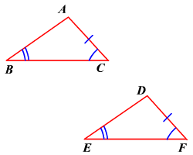

Side-Side-Side Similarity Postulate

Definition: Triangles are congruent if all three sides in one triangle are congruent to the corresponding sides in the other.

Illustration:

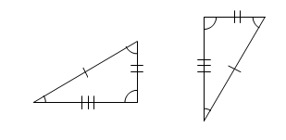

Examples:

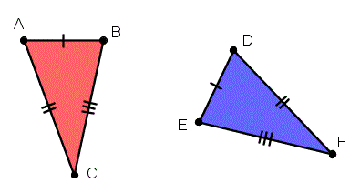

Side-Angle-Side Similarity Postulate

Definition: If two sides and the included angle of a triangle are congruent to two sides and the included angle of another triangle, then the two triangles are congruent.

Illustration:

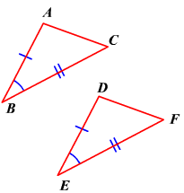

Examples:

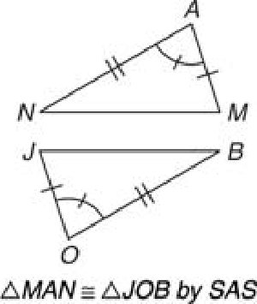

**Week 14**

the Pythagorean theorem

Definition: The theorem that the sum of the squares of the lengths of the sides of a right triangle is equal to the square of the length of the hypotenuse.

Illustration:

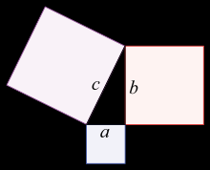

Examples:

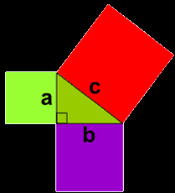  
Hypotenuse

Definition: The longest side of the triangle

Illustration:

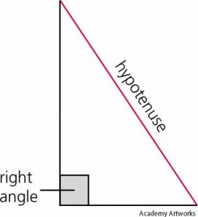

Examples:

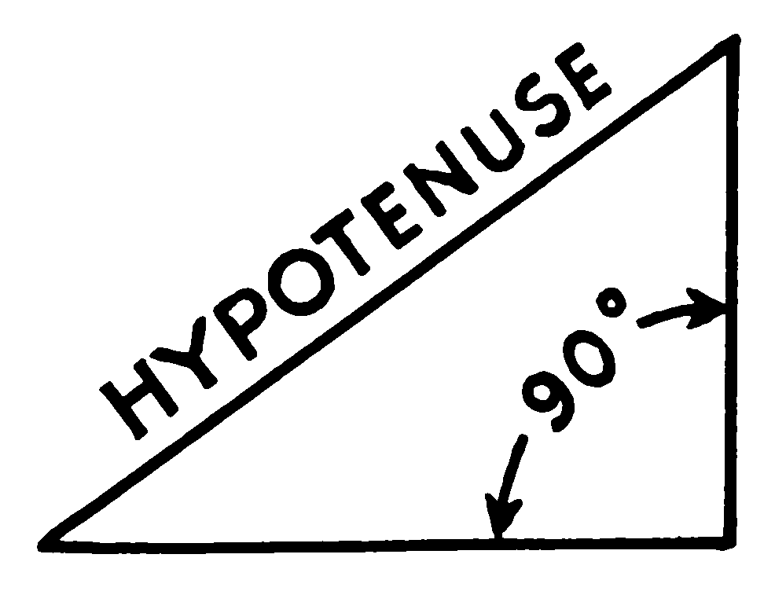  
Pythagorean Triples

Definition: consists of three positive integers a, b, and c, such that a2 + b2 = c2.

Illustration:

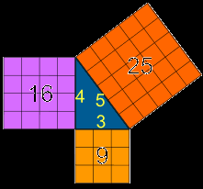

Examples:

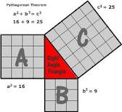  
The converse of the Pythagorean Theorem

Definition: the converse states that whenever the sum of the squares of two sides equal to the square of the third side of the triangle, the triangle is a right triangle.

Illustration:

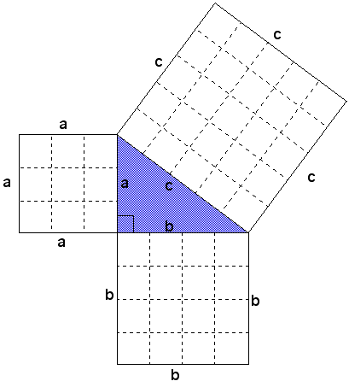

Examples:

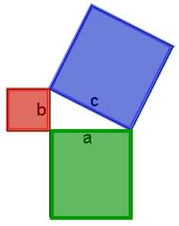

**Week 15**

30°-60°-90° triangle

Definition: is a special type of right triangle where the three angles measure 30 degrees, 60 degrees, and 90 degrees.

Illustration:

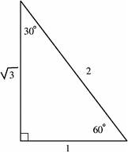

Examples:

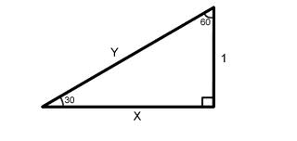  
45°-45°-90° triangle

Definition: A right triangle where the angles are 45°, 45°, and 90°.

Illustration:

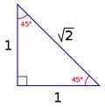

Examples:

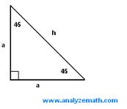  
Hypotenuse

Definition: the side of a right triangle opposite the right angle.

Illustration:

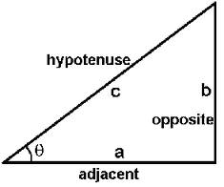

Examples:

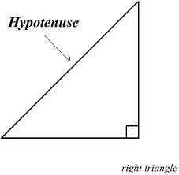

Opposite side of triangle

Definition: The opposite side of a triangle is the side that is not adjacent to the specified vertex.

Illustration:



Examples:

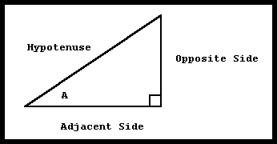

Adjacent side of a triangle

Definition: The other two sides are adjacent sides to the specified vertex.

Illustration:



Examples:

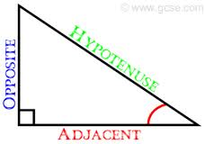

Sine

Definition: The trigonometric function that is equal to the ratio of the side opposite a given angle (in a right triangle) to the hypotenuse.

Illustration:

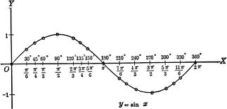

Examples:

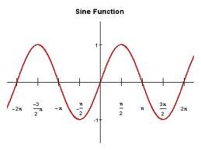

Cosine

Definition: The trigonometric function that is equal to the ratio of the side adjacent to an acute angle (in a right-angled triangle) to the hypotenuse.

Illustration:

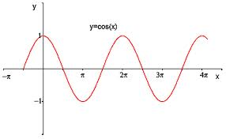

Examples:

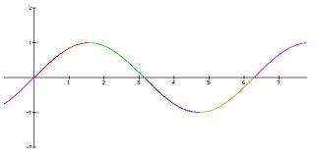

Tangent

Definition: A straight line or plane that touches a curve or curved surface at a point, but if extended does not cross it at that point.

Illustration:

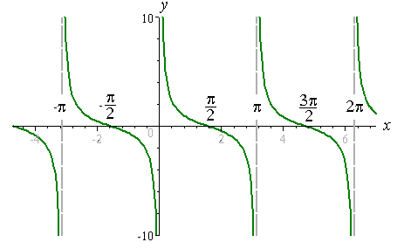

Examples:

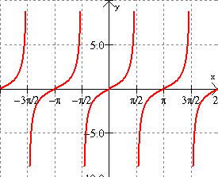

Angle of Depression

Definition: Angle of depression is the angle between a horizontal line and the line joining the observer's eye to some object beneath the horizontal line.

Illustration:

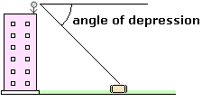

Examples:

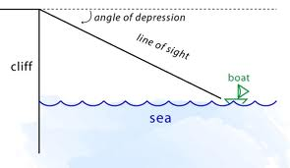

Inverse Sine

Definition: the inverse function of the sine; the angle that has a sine equal to a given number

Illustration:

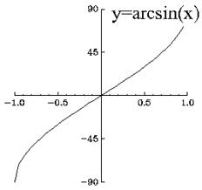

Examples:

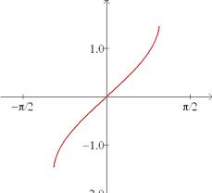  
Inverse Cosine

Definition: arc cosine: the inverse function of the cosine; the angle that has a cosine equal to a given number.

Illustration:

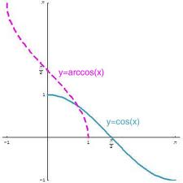

Examples:

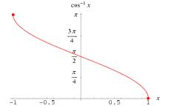

Inverse Tangent

Definition: arc tangent: the inverse function of the tangent; the angle that has a tangent equal to a given number.

Illustration:

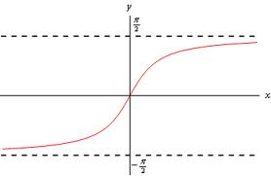

Examples:

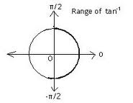

**Week 16**

Polygon

Definition: A plane figure with at least three straight sides and angles, and typically five or more.

Illustration:

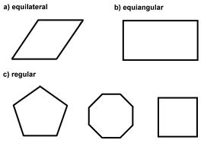

Examples:

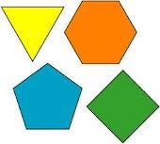  
Regular Polygon

Definition: a polygon with all sides and all angles equal.

Illustration:

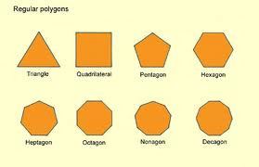

Examples:

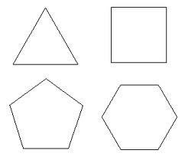  
Irregular Polygon

Definition: A polygon where not all the sides and angles are equal

Illustration:



Examples:

  
Convex

Definition: Having only interior angles measuring less than 180°

Illustration:

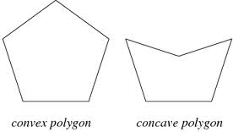

Examples:

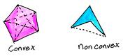  
Concave

Definition: Having an outline or surface that curves inward like the interior of a circle or sphere.

Illustration:



Examples:

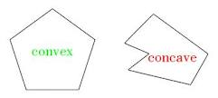  
Vertex

Definition: The highest point; the top or apex.

Illustration:

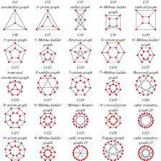

Examples:

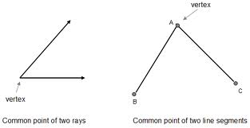

Interior Angle Sum Theorem

Definition: parallelogram is a quadrilateral with two sets of parallel sides -- opposite angels of the parallelogram is congruent while opposite sides of a parallelogram are equal lengths.

Illustration:

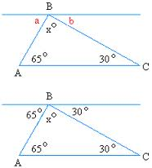

Examples:

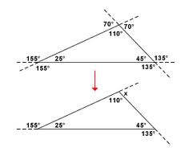  
Exterior Angle Sum Theorem

Definition: the angle between one side of a triangle and the extension of an adjacent side.

Illustration:

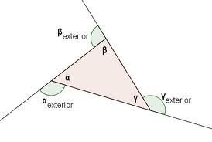

Examples:

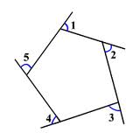  
Quadrilateral

Definition: A 4 sided figure.

Illustration:

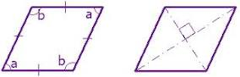

Examples:

  
Parallelogram

Definition: A four-sided plane rectilinear figure with opposite sides parallel.

Illustration:

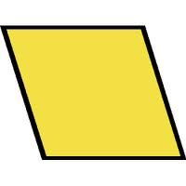

Examples:

  
Rectangle

Definition: A plane figure with four straight sides and four right angles, esp. one with unequal adjacent sides, in contrast to a square.

Illustration:

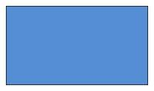

Examples:

  
Rhombus

Definition: A parallelogram with opposite equal acute and obtuse angles and four equal sides.

Illustration:



Examples:

  
Square

Definition: A plane figure with four equal straight sides and four right angles.

Illustration:



Examples:

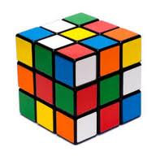

Trapezoid

Definition: A quadrilateral with only one pair of parallel sides.

Illustration:

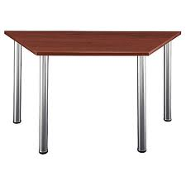

Examples:

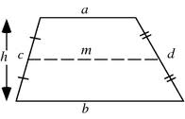  
Kite

Definition: In geometry a kite, or deltoid, is a quadrilateral with two disjoint pairs of congruent adjacent sides, in contrast to a parallelogram

Illustration:

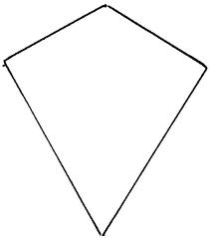

Examples:

  
Consecutive Angles

Definition: When two lines are crossed by another line (which is called the Transversal), the pairs of angles on one side of the transversal but inside the two lines are called Consecutive Interior Angles.

Illustration:

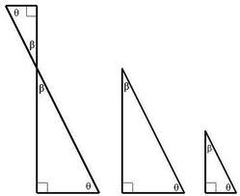

Examples:

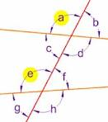  
Supplementary Angles

Definition: Either of two angles whose sum is 180°.

Illustration:

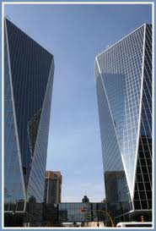

Examples:

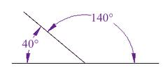  
Diagonal

Definition: Joining two opposite corners of a square, rectangle, or other straight-sided shape.

Illustration:

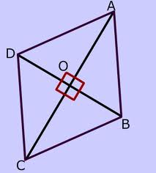

Examples:

  
Median

Definition: Denoting or relating to a value or quantity lying at the midpoint of a frequency distribution of observed values or quantities

Illustration:

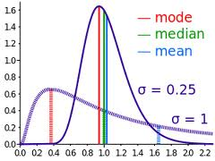

Examples:

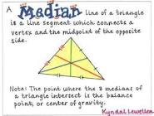

**Week 17**

Circle

Definition: A round plane figure whose boundary (the circumference) consists of points equidistant from a fixed center.

Illustration:

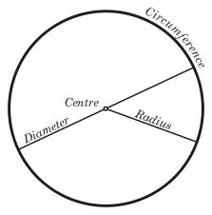

Examples:

  
Semi-Circle

Definition: A half of a circle or of its circumference.

Illustration:

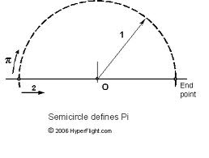

Examples:

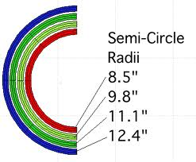  
Radius

Definition: A straight line from the center to the circumference of a circle or sphere.

Illustration:

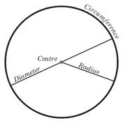

Examples:

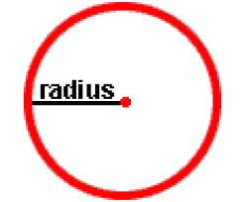  
Diameter

Definition: A straight line passing from side to side through the center of a body or figure, esp. a circle or sphere.

Illustration:



Examples:

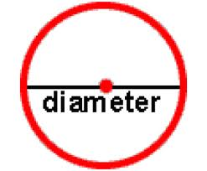

Circumference

Definition: The enclosing boundary of a curved geometric figure, esp. a circle.

Illustration:



Examples:

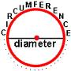  
Chord

Definition: A straight line joining the ends of an arc.

Illustration:

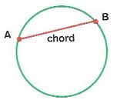

Examples:

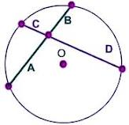  
Secant

Definition: The ratio of the hypotenuse to the shorter side adjacent to an acute angle (in a right-angled triangle); the reciprocal of a cosine.

Illustration:

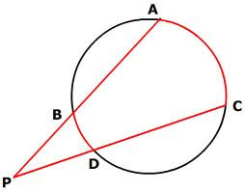

Examples:

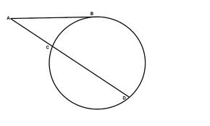  
Tangent

Definition: A straight line or plane that touches a curve or curved surface at a point, but if extended does not cross it at that point.

Illustration:

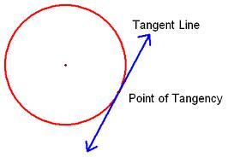

Examples:

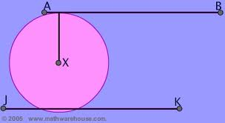  
Central Angle

Definition: A central angle is an angle whose vertex is the center of a circle, and whose sides pass through a pair of points on the circle

Illustration:

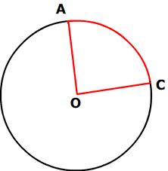

Examples:

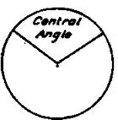  
Inscribed Angle

Definition: is formed when two secant lines of a circle (or, in a degenerate case, when one secant line and one tangent line of that circle) intersect on the circle.

Illustration:

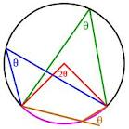

Examples:

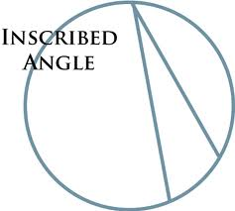  
Arc Addition Postulate

Definition: The measure of an arc formed by two adjacent arcs is the sum of the measures of the two arcs.

Illustration:

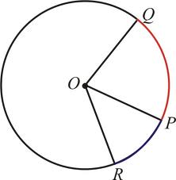

Examples:

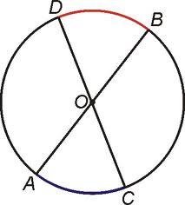  
Arc Lenght Formula

Definition: to calculate it from the radius and central angle of the arc.

Illustration:

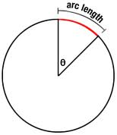

Examples:

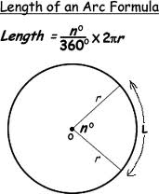  
Sector of a Circle

Definition: A circular sector or circle sector, is the portion of a circle enclosed by two radii and an arc,

Illustration:

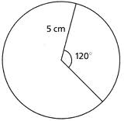

Examples:

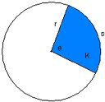  
Area of a Sector Formula

Definition: The area of a part of the interior of a circle bounded by two radii & an arc.

Illustration:

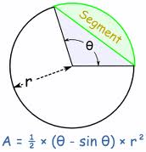

Examples:

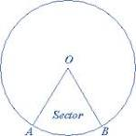

**Week 18**

Perimeter

Definition: The continuous line forming the boundary of a closed geometric figure.

Illustration:

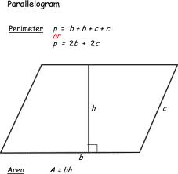

Examples:

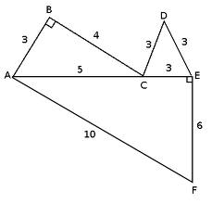  
Area

Definition:

Area is a quantity expressing the two-dimensional size of a defined part of a surface, typically a region bounded by a closed curve

Illustration:

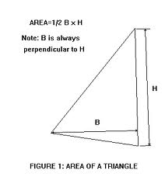

Examples:

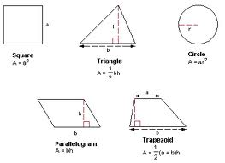  
Surface Area

Definition: the extent of a 2-dimensional surface enclosed within a boundary

Illustration:

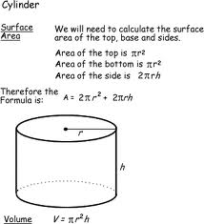

Examples:

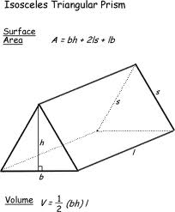  
Volume

Definition: the amount of space a 3-D object can hold

Illustration:

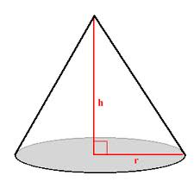

Examples:

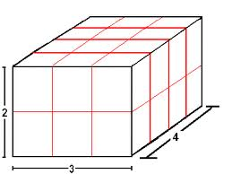  
Geometric Net

Definition: - a 2-D figure that can be folded on its segments or curved on its boundaries to form a 3-D figure.

Illustration:

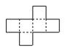

Examples:

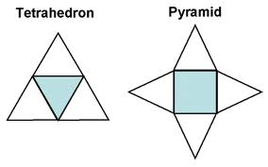  
Prism

Definition: A solid geometric figure whose two end faces are similar, equal, and parallel rectilinear figures, and whose sides are parallelograms.

Illustration:

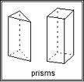

Examples:

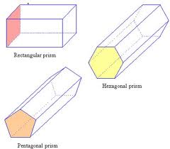

Cylinder

Definition: A solid geometric figure with straight parallel sides and a circular or oval section.

Illustration:

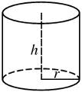

Examples:

  
Circle

Definition: A round plane figure whose boundary (the circumference) consists of points equidistant from a fixed center.

Illustration:



Examples:

  
Radius

Definition: A straight line from the center to the circumference of a circle or sphere.

Illustration:



Examples:

  
Diameter

Definition: A straight line passing from side to side through the center of a body or figure, esp. a circle or sphere.

Illustration:



Examples:



Circumference

Definition: The enclosing boundary of a curved geometric figure, esp. a circle.

Illustration:



Examples:



Pyramid

Definition: A solid object where , The base is a polygon (a straight-sided shape), The sides are triangles which meet at the top (the apex).

Illustration:

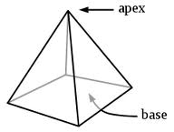

Examples:

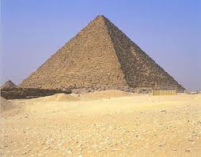  
Cone

Definition: A solid or hollow object that tapers from a circular or roughly circular base to a point.

Illustration:

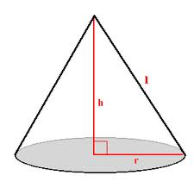

Examples:

  
Slant Height

Definition: The slant height is the distance from any point on the apex to the base

Illustration:

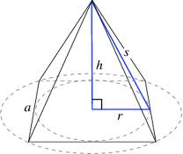

Examples:

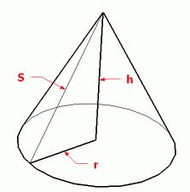  
Sphere

Definition: A round solid figure, or its surface, with every point on its surface equidistant from its center.

Illustration:

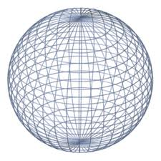

Examples:



**Week 18 Pt. 2**

Consistent

Definition: Having at least one common solution, as of two or more equations or inequalities.

llustration:

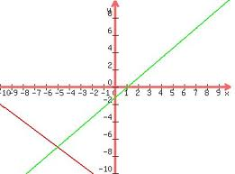

Examples:

  
Inconsistent

Definition: Not solvable for the unknowns by the same set of values. Used of two or more equations or inequalities.

Illustration:



Examples:

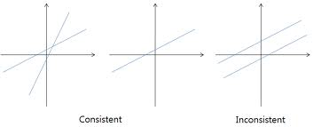  
System of Equaitons

Definition: simultaneous equations are a set of equations containing multiple variables

Illustration:

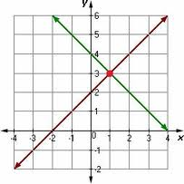

Examples:

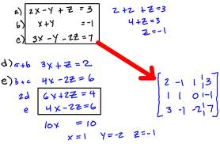

System of Inequalities

Definition: an inequality is a statement about the relative size or order of two objects

Illustration:

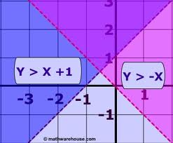

Examples:

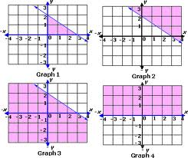  
Inequality with a solid line

Definition: draw your number line, find the "equals"part, mark this point with the appropriate notation , and then you'd shade everything to the right, because "greater than" meant "everything off to the right"

Illustration:

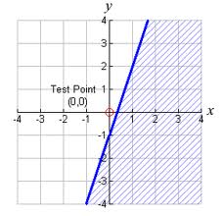

Examples:

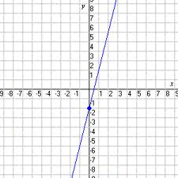

Inequality with a broken(dashed) line

Definition: If the inequality is "<" or ">" then connect the two points with a dotted line. The dotted line is analogous to the open circle on the number line.

Illustration:

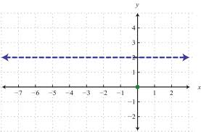

Examples:

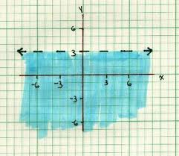

**[**

**Lesson 15:**

Definition:

Illustration:

Examples:

**Lesson 16:**

Definition:

Illustration:

Examples:

**Lesson 17:**

Definition:

Illustration:

Examples:

**Lesson 18:**

Definition:

Illustration:

Examples: